Antarctic Peninsula Automatic Weather Station Network
2014-15 Field Season Review

Rosey Grant¹, Steve Colwell, Petra Mildeova, Mairi Simms
British Antarctic Survey

t
- Overview
The British Antarctic Survey (BAS) currently runs a network of nine automatic weather stations (AWS) located on the Antarctic Peninsula and in the Halley region. Through an ongoing collaboration with the University of Utrecht, BAS is also responsible for the servicing of a small network of AWS on the Larsen ice shelf. AWS locations are shown in figure 1.
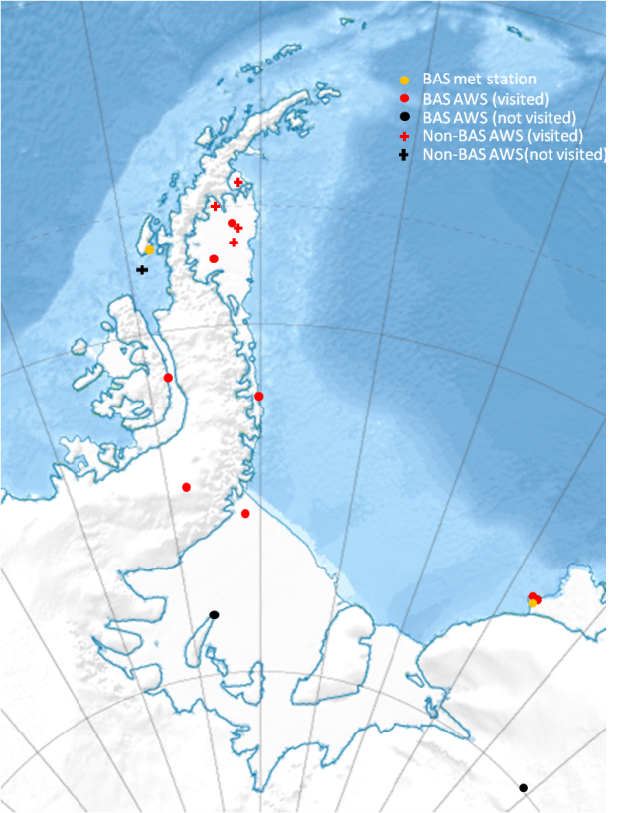
Figure 1: Peninsula and Brunt ice shelf AWS

All BAS stations measure wind speed, wind direction, temperature, pressure and relative humidity. Data is logged to a Campbell CR1000 data logger and ten minute averaged data is saved to a data card. Ten minute averaged data are transmitted via SBD Iridium every three hours and relayed as SYNOPS on the GTS. Once a week the complete data set is sent via Iridium. The AWS are powered by 100Ah 12V lead acid batteries, charged by solar panel. Assuming normal service, these stations need only be visited to raise the instruments above snow accumulation and to retrieve and replace data cards. Visits usually take place every one or two years.

- 2014-15 season
This season all sites, except Dismal Island and Korff, were visited for data retrieval and instrument raising. The AWS at Dismal Island belongs to the University of Wisconsin. It has not been visited since 2009 and is no longer working. The University of Wisconsin provided a complete new station to be installed at this site. The service was to happen from the RRS Ernest Shackleton at the end of the season but the trip was cancelled due to time constraints. The station remains at Rothera, ready for installation.

During the 2013-14 season a BAS AWS was installed at Korff ice rise to provide climatological information of the area in preparation for a drilling project due to commence in 2016-17. A visit to the Korff AWS was not necessary this season.

University of Utrecht
On the Larsen C ice shelf, the southernmost AWS belonging to the University of Utrecht was removed after 5 years service. The University of Utrecht have developed a new model of AWS, an intelligent Weather Station (iWS). An iWS was installed at each of the two remaining Utrecht sites. They will run alongside the current AWS for two years (figure 2). After this time the old style AWS will be removed. A third iWS was installed at a new site on Cabinet Inlet. The iWS is a small unit (18x22x12cm) which comprises a power system (solar panels and lithium batteries), logger and all sensors except wind and radiation. 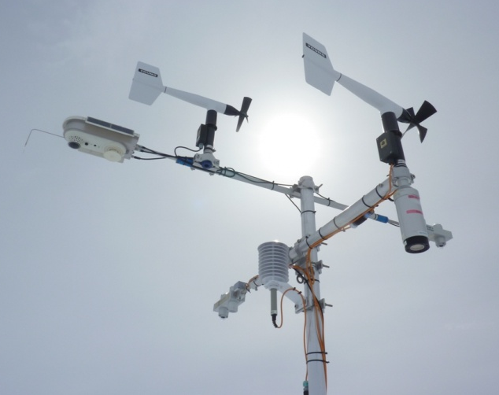
Figure 2. A University of Utrecht iWS mounted alongside an AWS on the Larsen C ice shelf.

- Issues encountered
Last season it was observed that several of the data cards retrieved from the BAS AWS were unreadable. The card readers at each site were replaced this season and only Campbell-recommended data cards were used. Servicing visits next year will prove whether this has been successful. It has further been suggested that older programs on the CR1000 may not be able to write to newer, larger memory cards. If problems persist during the 2015-16 season then smaller cards will be used.

- Intentions for 2015-16 season
As always, this field season will see operations based from Rothera and Halley. It is the intention that all AWS will be visited for data retrieval and instrument raising, as necessary, including the Korff AWS. A second request to visit Dismal Island has been submitted.

Corresponding author: Rosey Grant High Cross, Madingley Road, Cambridge. CB0 3ET E-mail: eleant@bas.ac.uk Telephone: 01223 221345

